HONORS CHEMISTRY • UNIT 0
Measurement & Math Skills
Every number in chemistry comes from a measurement. Learn to take them, write them, and work with them honestly.

HOW TO USE THIS PACKET
This is your notebook for the unit. Write definitions in your own words, copy the steps of each worked example, and use the blank space for sketches and questions. Boxes marked LAB CORNER are things you would do or see at a lab bench. Extra practice is at the back.

What we will learn
0.1 | Making accurate measurements
0.2 | Significant figures & scientific notation
0.3 | Calculations with significant figures
0.4 | Dimensional analysis (unit conversions)
0.5 | Density
★ | Extra practice, error analysis & unit review

By the end of this unit I can…
• Choose the right piece of lab equipment and read a scale to the correct decimal place.
• Tell accuracy from precision and use percent error.
• Count significant figures and round correctly; write numbers in scientific notation.
• Add, subtract, multiply and divide measurements and report the right number of sig figs.
• Convert between units with multi-step dimensional analysis (including squared and cubed units).
• Calculate density, mass or volume and identify a substance from its density.
• Design a simple lab procedure and explain where measurement error comes from.
TOPIC  0.1 | Making Accurate Measurements  Choosing tools • reading scales • accuracy vs precision

BIG IDEA
A measurement has two kinds of digits: the digits the tool lets you be certain about, and one estimated digit that you guess by eye. You always report all of them — and no more.

Key vocabulary — write each definition in your own words
Term | Definition (your words) | Example / sketch
Measurement | A number + a ____ ; what two kinds of digits does it contain?
Estimated digit | Where does it come from? Which digit in a reading is it?
Accuracy | Compared to what?
Precision | Compared to what?
Meniscus | Draw it. Where do you read it?

THINK OF IT LIKE… A CAR SPEEDOMETER
The speedometer has marks every 10 mph. If the needle sits a bit past 60, you would say "about 64." The 6 you were sure about; the 4 is your best estimate between the marks. A lab measurement works exactly the same way. Accuracy vs. precision: a basketball player who hits the same spot on the backboard every time (but never the hoop) is precise, not accurate.

How to read ANY scale (cylinder, buret, ruler, thermometer)
CUES / KEY WORDS  Step 1  Step 2  Step 3  Step 4 | WRITE THE FOUR STEPS IN YOUR OWN WORDS

LAB CORNER • Choosing the right tool

Chemists choose glassware based on how precisely they need to know a volume. Study the pieces below.
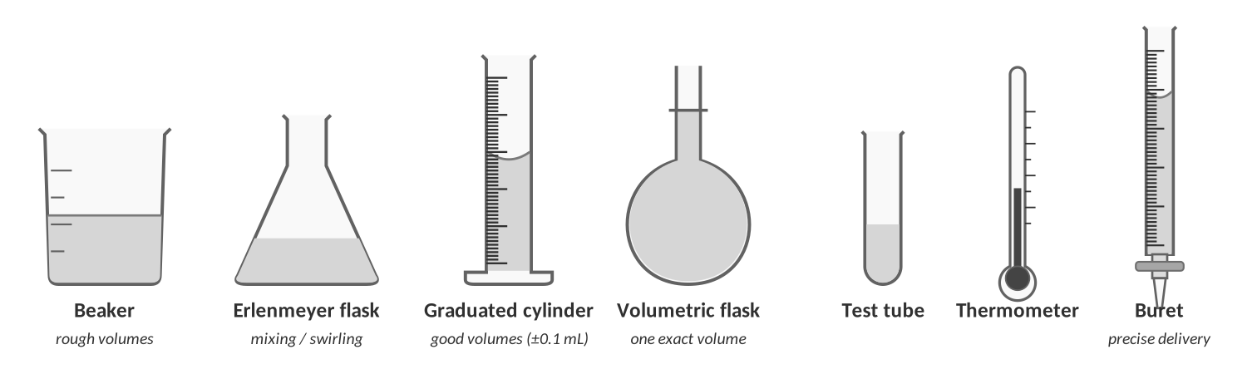
Common lab glassware and measuring tools (not to scale).
The job | Best tool | Why?
Deliver an exact, adjustable volume of acid drop by drop (titration)
Make exactly 250.00 mL of a solution with a known concentration
Measure 37.4 mL of water for a reaction
Heat and stir roughly 100 mL of a solution
Swirl a reaction mixture without splashing

LAB CORNER • Reading scales

Each drawing below is a zoomed-in piece of a real instrument. Read the bottom of the meniscus. Remember: certain digits + one estimated digit.
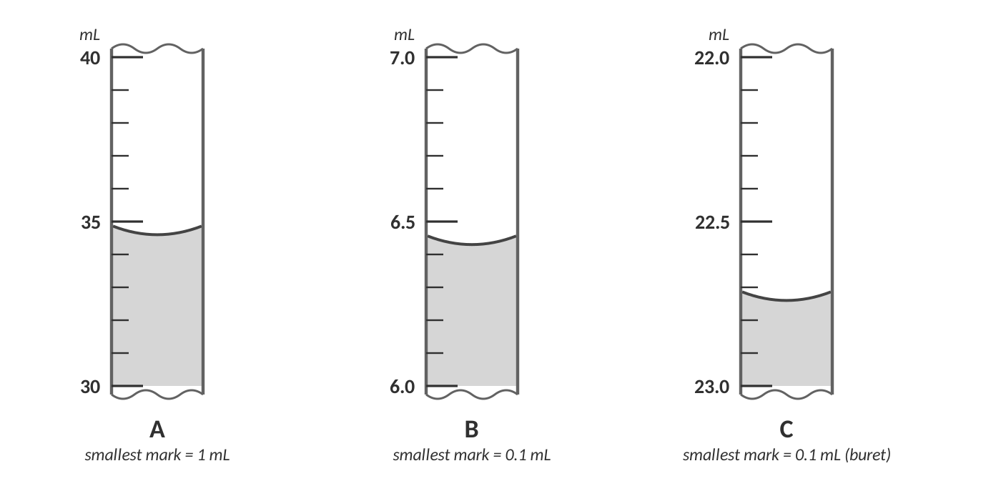
Scale readings A, B and C.
 | Smallest mark is worth | Reading (with unit) | Which digit is estimated? | # of sig figs
A
B
C (buret)

1. A classmate reads cylinder A as "35 mL" and another reads it as "34.60 mL." Explain what is wrong with each reading.

2. Why does a buret reading to 22.74 mL have more significant figures than the cylinder reading of 34.6 mL? What does that tell you about the tool?

LAB CORNER • The meniscus and eye level

Water sticks to glass, so the liquid climbs the walls and forms a curve.
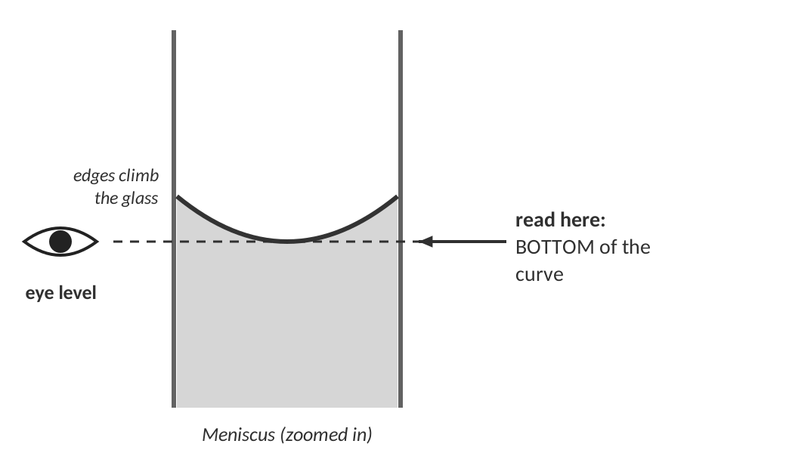
Always read at eye level, at the bottom of the curve.
3. Why does water form a meniscus that curves up at the walls?

4. Draw a picture of what the meniscus would look like if you looked at the cylinder from slightly above the surface. Explain how this could make your reading wrong.

LAB CORNER • Length with two different rulers

The same metal strip is measured with two rulers. Ruler 1 has marks every 1 cm; Ruler 2 has marks every 0.1 cm.
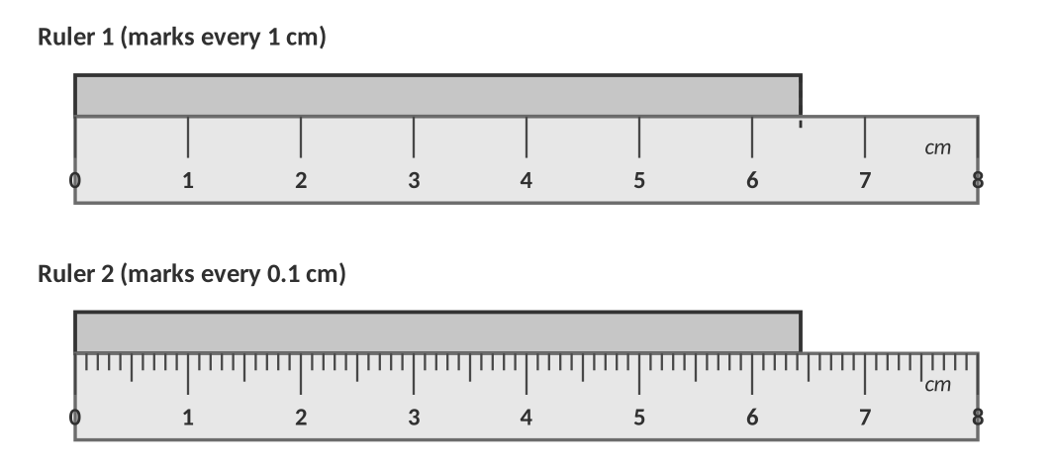
 | Smallest mark | Reading | Estimated digit
Ruler 1
Ruler 2

5. Both readings are "correct." Why do they have different numbers of significant figures?

[ IMAGE GOES HERE ]
Optional: photo or AP exam figure of a buret / graduated cylinder reading (homework Topic 0.1 figures)

LAB CORNER • Accuracy and precision

Four students throw darts at a target. The bullseye is the true value.
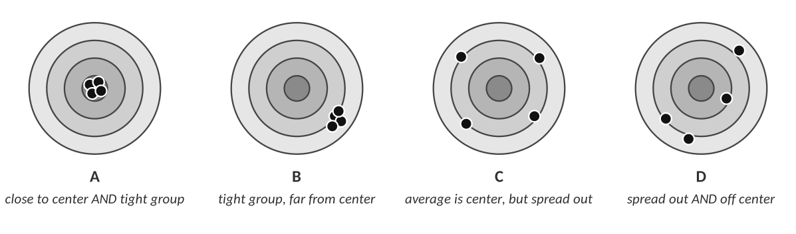
Target | Accurate? | Precise?
A
B
C
D

6. Three students each measure a 10.00 g standard mass three times.
a. Student 1: 10.01 g, 10.02 g, 10.00 g. Student 2: 9.52 g, 9.51 g, 9.53 g. Student 3: 9.2 g, 10.6 g, 10.0 g.
b. Describe the accuracy and precision of each student.

PERCENT ERROR
% error = |measured − accepted| ÷ accepted × 100
Use it to describe accuracy as a single number. Example: A student finds the density of iron to be 8.22 g/mL; the accepted value is 7.87 g/mL. % error = |8.22 − 7.87| ÷ 7.87 × 100 = 4.45 %

WATCH OUT!
Precision does not guarantee accuracy. A balance that is not zeroed gives beautifully precise wrong answers.

7. Quick check — which is a better description of a systematic error: a balance that always reads 0.30 g too high, or a student who sometimes reads the cylinder from above? Why?

TOPIC  0.2 | Significant Figures & Scientific Notation  Which digits count • rounding • writing very large and small numbers

BIG IDEA
Significant figures (sig figs) tell the reader how well you know a number. Sig figs = all certain digits + the one estimated digit.

THINK OF IT LIKE… A PHOTO’S RESOLUTION
"I live somewhere in Tennessee" and "I live at 123 Main Street, Spring Hill" can both be true — but one has far more detail. A number with more sig figs is a sharper picture. If someone says "about 1500 people were at the game," the trailing zeros are placeholders (a rounded estimate). If an attendance scanner reports "1500." it counted every one. The decimal point is the signal.

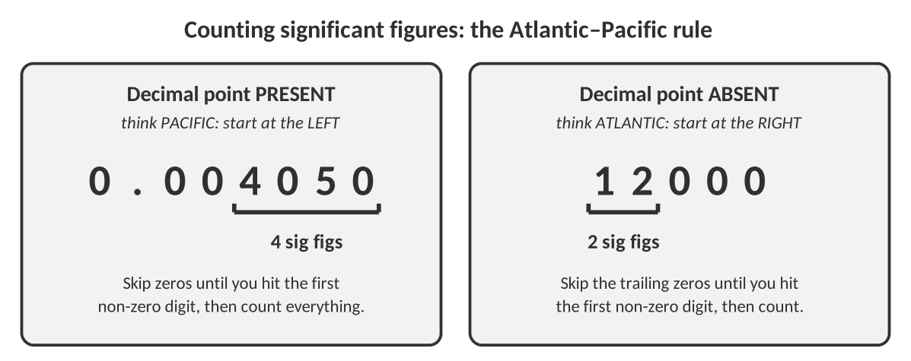
Build the rules — write each rule in your own words
Type of digit | The rule (your words) | Example | Sig figs
Non-zero digits |  | 4.37 and 437
Captive zeros |  | 5004 and 1.002
Leading zeros |  | 0.0052
Trailing zeros WITH a decimal point |  | 25.00 and 100.
Trailing zeros WITHOUT a decimal point |  | 1500 and 90
Exact numbers |  | 24 students; 12 in = 1 ft

WATCH OUT!
Scientific notation removes the confusion. 1500 has 2 sig figs, but 1.500 × 10³ has 4. Every digit in the coefficient (the part before ×10) is significant.

Practice A — count the significant figures
Number | # sig figs | Number | # sig figs
4.056 |  | 0.00340
1200 |  | 1200.
6.0200 |  | 0.0809
3.0 × 10⁵ |  | 450.0
90 |  | 0.10
5,000,100 |  | 1.00 × 10⁻³

1. Explain the difference between the numbers 100, 100. and 1.00 × 10².

Rounding to a given number of sig figs
ROUNDING RULE
Look at the digit just after the last one you are keeping. If it is 5 or more, round the last kept digit up; if it is 4 or less, leave it alone.
Keep the number the same size: fill the lost places with zeros (or use scientific notation so the zeros are not misleading).

Number | 4 s.f. | 3 s.f. | 2 s.f.
58,364
0.004528
19.95

Scientific notation
CUES / KEY WORDS  Format  Moving the decimal  Why use it? | NOTES — FILL IN DURING THE MINI-LESSON

THINK OF IT LIKE… ZOOMING A MAP
Scientific notation is a zoom dial. A big positive exponent zooms way out (the whole galaxy); a big negative exponent zooms way in (a single atom). The coefficient is the "what you see," and the exponent is the zoom level.

Write in scientific notation | Keep this many s.f. | Answer
93,000,000 | 2
0.000000450 | 3
12,500 | 3
0.0820 | 3
602,200,000,000,000,000,000,000 | 4

Write in standard form | Answer
3.4 × 10³
6.02 × 10⁻³
1.50 × 10²
8.0 × 10⁻⁵

2. Both 3.4 × 10³ and 3400 can describe the same value. Why might a scientist prefer 3.4 × 10³? How would you write 3400 so that it has 4 sig figs?

TOPIC  0.3 | Calculations with Significant Figures  Add/subtract vs multiply/divide • don’t round until the end

BIG IDEA
A calculator answer is not a measurement. Your final answer can never be more certain than your least certain measurement.

Two rules — two different questions
Operation | Look at… | Your answer gets… | Why?
Add / Subtract
Multiply / Divide

THINK OF IT LIKE… TWO DIFFERENT “WEAKEST LINKS”
Adding is like stacking planks: if one plank was measured to the nearest meter and another to the nearest millimeter, the stack is only trustworthy to the nearest meter — the place value of the sloppiest measurement decides. Multiplying is like a relay race: the team result can't be more reliable than its least reliable runner, so the number of sig figs of the weakest measurement decides.

WATCH OUT!
• Don't round in the middle of a problem. Carry an extra digit and round once at the end.
• Exact numbers (24 hours in a day; 12 in = 1 ft) never limit the answer.
• In a mixed problem, do the steps in order and apply the right rule at each step.

WORKED EXAMPLE — ADD / SUBTRACT
12.11 cm + 18.0 cm + 1.013 cm = ?

Work it out here:

Answer: __________________________________
WORKED EXAMPLE — MULTIPLY / DIVIDE
6.38 cm × 2.0 cm = ?

Work it out here:

Answer: __________________________________
WORKED EXAMPLE — MIXED OPERATIONS
(4.58 g + 1.2 g) ÷ 3.45 mL = ?

Work it out here:

Answer: __________________________________
Practice: write the calculator answer, then the answer with correct sig figs
Problem | Calculator answer | Answer with sig figs
5.72 cm + 3.1 cm
12.40 g − 0.337 g
150 m + 25.4 m
150. m + 25.4 m
2.50 cm × 4.1 cm
15.0 g ÷ 4.2 mL
0.0821 × 298
(6.02 × 10²³) × 0.0500
(25.0 − 4.8) × 3.2
8.314 × 273.15 ÷ 101.3

1. Error analysis. A student calculates the area of a lab bench that is 2.0 m long and 0.85 m wide and writes 1.700 m². Find the mistake and write the correct answer.

2. Reasoning. Why can't you use the "fewest sig figs" rule when adding 8.4 m + 10.0 m? What rule do you use and what is the answer?

TOPIC  0.4 | Dimensional Analysis  Multiplying by 1 in disguise • SI prefixes • multi-step conversions

BIG IDEA
A conversion factor is a fraction that equals 1, because the top and the bottom are the same amount written in different units. Multiplying by 1 changes the units but not the amount.

THINK OF IT LIKE… EXCHANGING MONEY
$1 = 100 ¢ is a true statement, so (100 ¢ / $1) is just "1." Converting $5 into cents is multiplying by 1: $5 × (100 ¢ / $1) = 500 ¢. The dollar sign cancels and cents remain. Dimensional analysis is simply that, with any units you want.

Key vocabulary — write each definition in your own words
Term | Definition (your words) | Example / sketch
Equality | Two ways of writing the same amount.
Conversion factor | How do you make one from an equality?
Cancel units | What does “cancel” mean?

Make two conversion factors from every equality
Equality | Conversion factor 1 | Conversion factor 2
1 in = 2.54 cm
1 mi = 5280 ft
1 kg = 1000 g
1 L = 1000 mL
60 s = 1 min

SI prefixes — fill in the missing information
Prefix | Symbol | Meaning (power of ten) | Example
kilo-
 | c
milli-
micro-
nano-
mega-

The steps
CUES / KEY WORDS  1  2  3  4  5 | WRITE YOUR OWN STEP-BY-STEP RECIPE

SIG FIGS AND CONVERSIONS
Defined equalities such as 12 in = 1 ft or 60 s = 1 min are exact and never limit your answer. A measured equality (1 gal = 3.79 L) or the number you start with does. Always count sig figs on the given measurement.

WORKED EXAMPLE — A ONE-STEP CONVERSION
A lab bench is 48.2 cm wide. How many inches is that? (1 in = 2.54 cm)

Work it out here:

Answer: __________________________________
WORKED EXAMPLE — A RATE CONVERSION (TWO UNITS CHANGE)
A car travels at 65 mi/h. What is its speed in m/s? (1 mi = 5280 ft; 1 ft = 12 in; 1 in = 2.54 cm; 100 cm = 1 m; 1 h = 3600 s)

Work it out here:

Answer: __________________________________
WORKED EXAMPLE — SQUARED AND CUBED UNITS (HONORS EXTENSION)
How many cm³ are in 1.0 m³? Hint: 100 cm = 1 m, and you must cube the whole factor.

Work it out here:

Answer: __________________________________
WATCH OUT!
When a unit is squared or cubed, raise the entire conversion factor to that power. 1 m² is 10,000 cm², not 100 cm².

LAB CORNER • Chemistry at the bench

Every lab calculation you do this year is a dimensional analysis problem in disguise. Try these lab-style conversions.
1. A buret delivers 23.45 mL of acid. Convert this volume to liters.
Work:

Answer (units & sig figs): __________________________________
2. Convert the same 23.45 mL to microliters (µL).
Work:

Answer (units & sig figs): __________________________________
3. A procedure calls for 0.250 L of water, but you only have a 50.0 mL graduated cylinder. How many full cylinders must you pour?
Work:

Answer (units & sig figs): __________________________________
Practice — show ALL work, even if you can do it in your head
4. A basketball court is 94.0 ft long. How many meters is that? (1 ft = 12 in; 1 in = 2.54 cm; 100 cm = 1 m)
Work:

Answer (units & sig figs): __________________________________
5. A marathon is 26.2 mi. How many kilometers is that? (1.00 mi = 1.61 km)
Work:

Answer (units & sig figs): __________________________________
6. A cheetah sprints at 88.0 ft/s. What is that speed in mi/h? (5280 ft = 1 mi; 60 s = 1 min; 60 min = 1 h)
Work:

Answer (units & sig figs): __________________________________
7. A patient is prescribed 15 mg of medicine per kg of body mass. The patient weighs 142 lb. How many mg should be given? (1 kg = 2.20 lb)
Work:

Answer (units & sig figs): __________________________________
8. Gasoline costs $3.45 per gallon. What is the price per liter? (1 gal = 3.79 L)
Work:

Answer (units & sig figs): __________________________________
9. A sample has a volume of 5.0 cm³. Express this volume in m³. (100 cm = 1 m)
Work:

Answer (units & sig figs): __________________________________
10. The diameter of a hydrogen atom is about 0.106 nm. Express this in cm. (1 nm = 10⁻⁹ m; 100 cm = 1 m)
Work:

Answer (units & sig figs): __________________________________
TOPIC  0.5 | Density  Mass ÷ volume • an identity fingerprint for matter

BIG IDEA
Density tells you how much mass is packed into a given volume. Because it doesn't depend on how much you have, it is a fingerprint that helps identify a substance.

THINK OF IT LIKE… A CROWDED VS. EMPTY THEATER
A theater has a fixed volume (the room). Fill it with 500 people and it is dense; with 50 people it is not. Same room, different amount of “stuff” inside. Another way: a bag of feathers and a bag of bricks take up the same space, but the bricks pack far more mass into it.

Key vocabulary — write each definition in your own words
Term | Definition (your words) | Example / sketch
Density | Write the equation and the units.
Intensive property | Does it change if you cut the sample in half?
Extensive property | Does it change if you cut the sample in half?
Displacement | How does it measure volume?

The density triangle — fill in all three forms
To find… | Use | Typical units
Density
Mass
Volume

REMEMBER
1 mL = 1 cm³ exactly. Liquids are usually measured in mL, solids in cm³ — the number is the same.

Three ways to find volume
Type of sample | How to get the volume | Tool(s)
Regular solid (box, cylinder)
Liquid
Irregular solid

LAB CORNER • Density tower

A student carefully pours four liquids into a tall cylinder. They separate into layers.
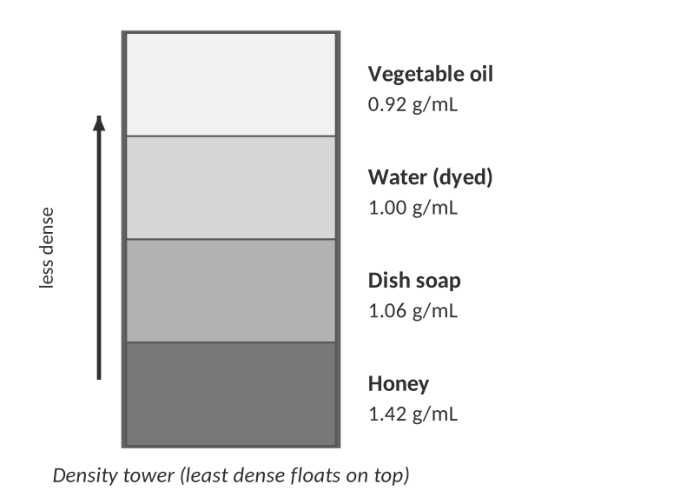
1. Why do the liquids stack in this order? Use the word density in your explanation.

2. A plastic bead with a density of 1.03 g/mL is dropped into the tower. Between which two layers will it come to rest? Explain.

LAB CORNER • Finding the density of a metal by displacement

A student masses an unknown metal sample, then lowers it into a graduated cylinder of water.
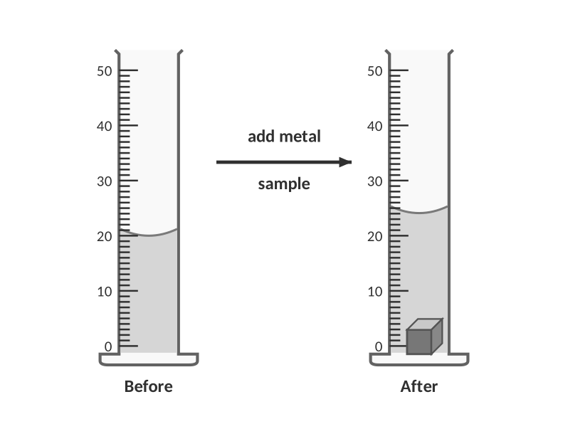
DATA
Mass of metal sample = 32.3 g. Water level before = 20.0 mL. Water level after = 24.1 mL.

3. Use the data above to analyze the metal sample.
a. Volume of the metal:
Work:

Answer (units & sig figs): __________________________________
b. Density:
Work:

Answer (units & sig figs): __________________________________
4. Identify the metal.

Substance | Density (g/cm³ or g/mL) | Substance | Density (g/cm³ or g/mL)
Magnesium | 1.74 | Zinc | 7.14
Aluminum | 2.70 | Iron | 7.87
Titanium | 4.51 | Copper | 8.96
Water (4 °C) | 1.00 | Lead | 11.34
Ethanol | 0.789 | Gold | 19.3
Ice (0 °C) | 0.917 | Mercury | 13.53

WATCH OUT!
The density of a block of aluminum does not depend on how big it is. A big block has a larger mass AND a larger volume — the ratio stays 2.70 g/cm³.

WORKED EXAMPLE — REGULAR SOLID
A rectangular block measures 3.00 cm × 2.50 cm × 4.20 cm and has a mass of 85.1 g. What is its density, and what metal could it be?

Work it out here:

Answer: __________________________________
WORKED EXAMPLE — LIQUID WITH A GRADUATED CYLINDER
An empty graduated cylinder has a mass of 45.30 g. With 20.0 mL of an unknown liquid it has a mass of 61.10 g. What is the density?

Work it out here:

Answer: __________________________________
Practice
5. Two blocks of pure copper are weighed: block A is 400 g and block B is 25 g. A student predicts block A has a higher density because it is heavier. Is the student right? Explain.

6. A gold bar has a mass of 1.00 kg. The density of gold is 19.3 g/cm³. What volume (in cm³) does the bar occupy?
Work:

Answer (units & sig figs): __________________________________
7. A sample of mercury (d = 13.53 g/mL) fills a 25.0 mL cylinder to the top. What is the mass of the mercury in grams?
Work:

Answer (units & sig figs): __________________________________
8. A 62.5 g metal sample is lowered into a cylinder that reads 32.0 mL. The water level rises to 39.0 mL. Calculate the density and identify the metal.
Work:

Answer (units & sig figs): __________________________________
9. Ice has a density of 0.917 g/cm³ and liquid water 1.00 g/cm³. What fraction of a floating ice cube is below the waterline? Explain in terms of density.

10. A can of regular soda sinks in water but a can of diet soda floats. Both cans have the same size and the same amount of liquid. Explain.

LAB CORNER • Design a lab

You are given a rubber stopper that floats and is too wide to fit into a graduated cylinder.
11. Describe a procedure (with the tools you would use) to measure the density of the stopper. Include how you would handle the fact that it floats.

PRACTICE
Extra Practice — Unit 0
Work these on your own or with a partner. Show all work.

A. Reading scales
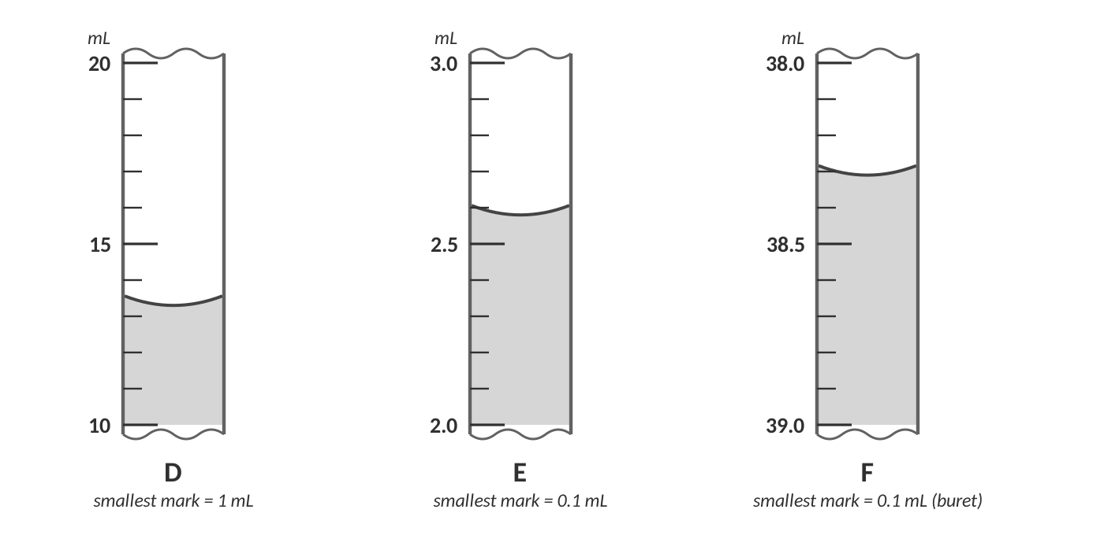
Scale readings D, E and F. Buret F reads downward.
 | Smallest mark | Reading with unit | Estimated digit is in the… place | # sig figs
D
E
F (buret)

1. A student must add exactly 25.00 mL of acid to a flask. Which tool should she choose, a 50 mL beaker or a buret? Explain using the idea of the estimated digit.

B. Significant figures
Number | # sig figs | Number | # sig figs
0.0070 |  | 7.0 × 10⁻³
2,040 |  | 2,040.
0.5000 |  | 300
3.00 × 10² |  | 1,004,000
0.020300 |  | 60.

Round to… | 63,849 | 0.008752 | 2.4850
3 s.f.
2 s.f.

2. Write 4,500,000 in scientific notation (a) with 2 sig figs and (b) with 4 sig figs.

3. Explain why 0.0050 g and 0.005 g are NOT the same measurement even though they look like the same amount.

C. Calculations with sig figs
Problem | Answer with correct sig figs
14.56 g + 3.2 g + 0.003 g
100.0 mL − 37.45 mL
4.00 cm × 2.50 cm × 1.0 cm
88.0 g ÷ 12.011
(12.5 + 0.75) × 2.00
(3.0 × 10⁴) × (2.50 × 10⁻²)
0.00560 ÷ 0.0200
12 eggs × 58.4 g per egg (12 is exact)

D. Dimensional analysis
4. A swimming pool holds 2.50 × 10⁴ gallons. How many liters is that? (1 gal = 3.79 L)
Work:

Answer (units & sig figs): __________________________________
5. A runner covers 5.00 km in 22.5 min. What is the speed in m/s?
Work:

Answer (units & sig figs): __________________________________
6. How many seconds are in a 365-day year? (Treat 365 as exact.)
Work:

Answer (units & sig figs): __________________________________
7. A drop of water is 0.050 mL. How many drops are in 1.00 L?
Work:

Answer (units & sig figs): __________________________________
8. The speed of light is 3.00 × 10⁸ m/s. Express this in mi/h. (1 mi = 1609 m)
Work:

Answer (units & sig figs): __________________________________
9. A room has a volume of 45.0 m³. What is the volume in liters? (1 m³ = 1000 L)
Work:

Answer (units & sig figs): __________________________________
E. Density
10. A cube of an unknown metal is 2.00 cm on each side and has a mass of 21.6 g. Calculate the density. Is the metal aluminum (2.70 g/cm³), zinc (7.14 g/cm³) or iron (7.87 g/cm³)?
Work:

Answer (units & sig figs): __________________________________
11. The density of ethanol is 0.789 g/mL. What volume of ethanol has a mass of 50.0 g?
Work:

Answer (units & sig figs): __________________________________
12. A piece of lead (d = 11.34 g/cm³) has a volume of 3.5 cm³. What is its mass?
Work:

Answer (units & sig figs): __________________________________
13. A student drops a solid into a cylinder and the level rises from 18.0 mL to 25.0 mL. The solid has a mass of 40.6 g. She reports its density as 5.8 g/mL. Another student says the density should be 5.80 g/mL. Who is right and why?

F. Lab data analysis
THE EXPERIMENT
A student finds the density of an unknown liquid three times, using different amounts. She uses a balance (±0.01 g) and a graduated cylinder. The accepted density of ethanol is 0.789 g/mL.

Trial | Mass of liquid (g) | Volume (mL) | Density (g/mL)
1 | 19.82 | 25.0
2 | 15.91 | 20.0
3 | 8.06 | 10.0

14. Calculate the average density and the percent error compared with the accepted value for ethanol.
Work:

Average density / % error: __________________________________
15. Are the three trials precise? Are they accurate? Explain.

16. Name one source of random error and one source of systematic error in this experiment, and how each would affect the results.

[ IMAGE GOES HERE ]
Optional: a photo of your lab station (balance, graduated cylinders, unknown liquids) or an AP-style lab diagram

G. Error analysis — find the mistake
17. A student converts 5.0 miles to feet like this: 5.0 mi × (1 mi / 5280 ft) = 0.00095 ft. What went wrong? Write the correct setup and answer.

18. A student measures a mass of 56.7 g and a volume of 5.0 mL and reports the density as 11.3400 g/mL. Give two things wrong with this answer and the correct result.

TOPIC  ★ | Unit 0 Review  Put it in your own words before the test

1. In two or three sentences, explain what significant figures tell someone who reads your data.

2. Explain the difference between the rules for adding and multiplying measurements. Give a one-line example of each.

3. Describe the steps of dimensional analysis as if you were explaining it to a friend who missed class.

4. Why is density called an identifying property of a substance, but mass is not?

5. Draw and label a quick sketch showing how to read the volume in a graduated cylinder. Include the meniscus, eye level and which digit is estimated.

